Phase 9: Reports and Dashboards

1. Introduction
Phase 9 of our Salesforce Consumer Goods Partner Portal project focused on creating reports and dashboards to provide insights into product data. The goal was to generate a Product Insights Report with detailed product information and a dashboard visualization for business users and partners.
Reports and dashboards allow stakeholders to analyze patterns, track product performance, and make informed decisions quickly.

2. Step-by-Step Implementation

2.1 Creating a Product Report
- Go to App Launcher (9-dot icon) → Select Reports.
- Click New Report.
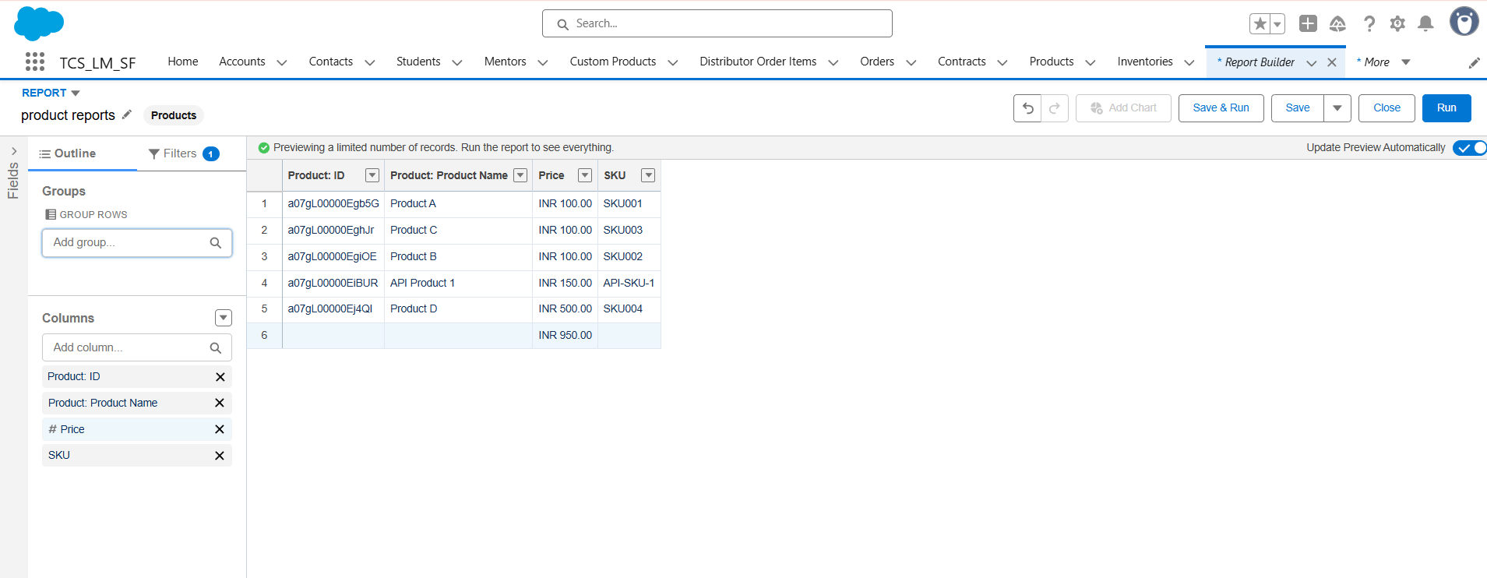
- From the available report types, search for and select Products.
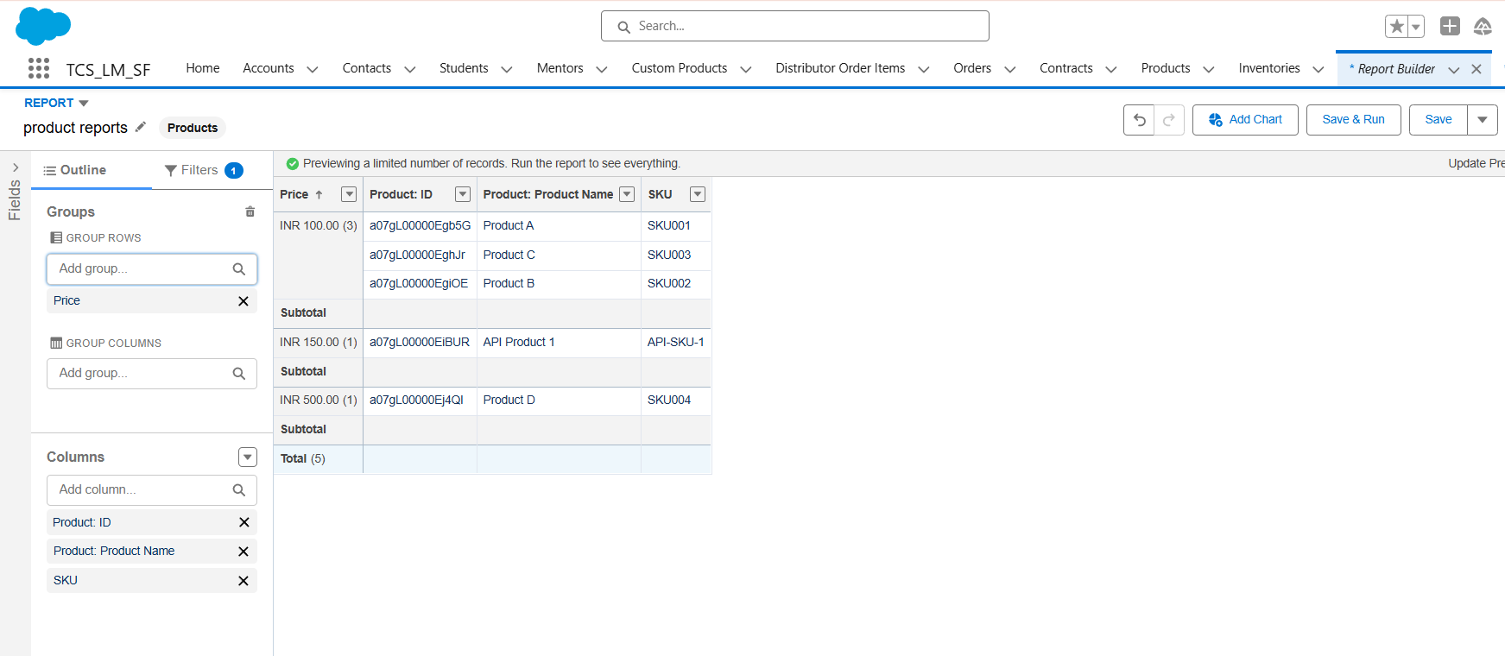
- Click Continue to open the report builder.

- In the Outline panel, add the following fields as columns:
  - Product ID
  - Product Name
  - Price
  - SKU
- In Group Rows, group by:
  - Price
  - SKU
- Save the report:
  - Report Name: Product Insights Report
  - Folder: Public Reports
- Run the report and verify the grouped structure.
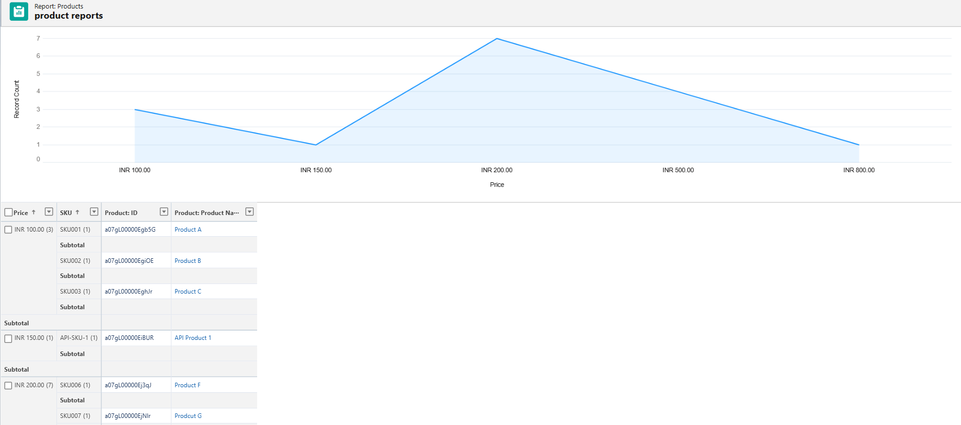

2.2 Creating a Product Dashboard
- Go to App Launcher → Dashboards.

- Click New Dashboard. Enter the details:
  - Dashboard Name: Product Insights Dashboard
  - Folder: Public Dashboards
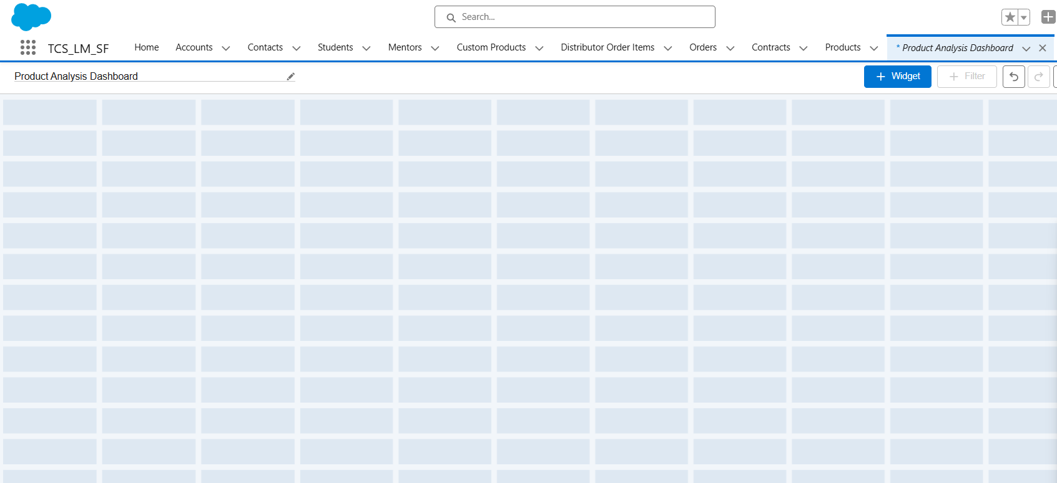
- Once in the Dashboard editor:
  - Click + Component
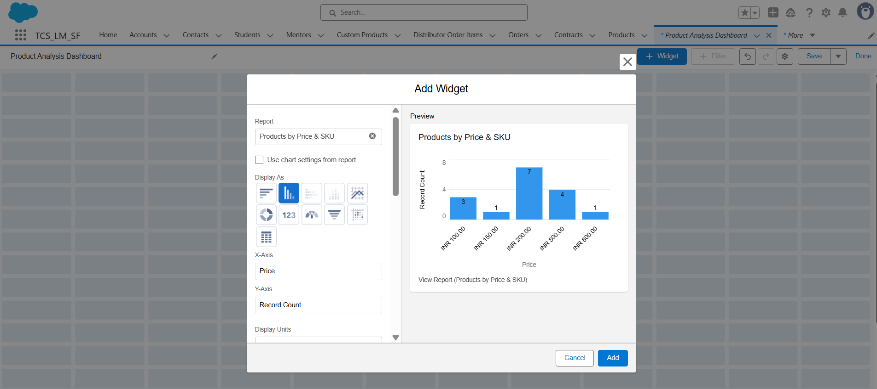
  - Choose the Product Insights Report created earlier

- Select a Bar Chart to compare product prices across SKUs.
- Configure the chart:
  - Title: Product Price by SKU
  - Group by SKU
  - Value: Sum of Price
- Save and refresh the dashboard.
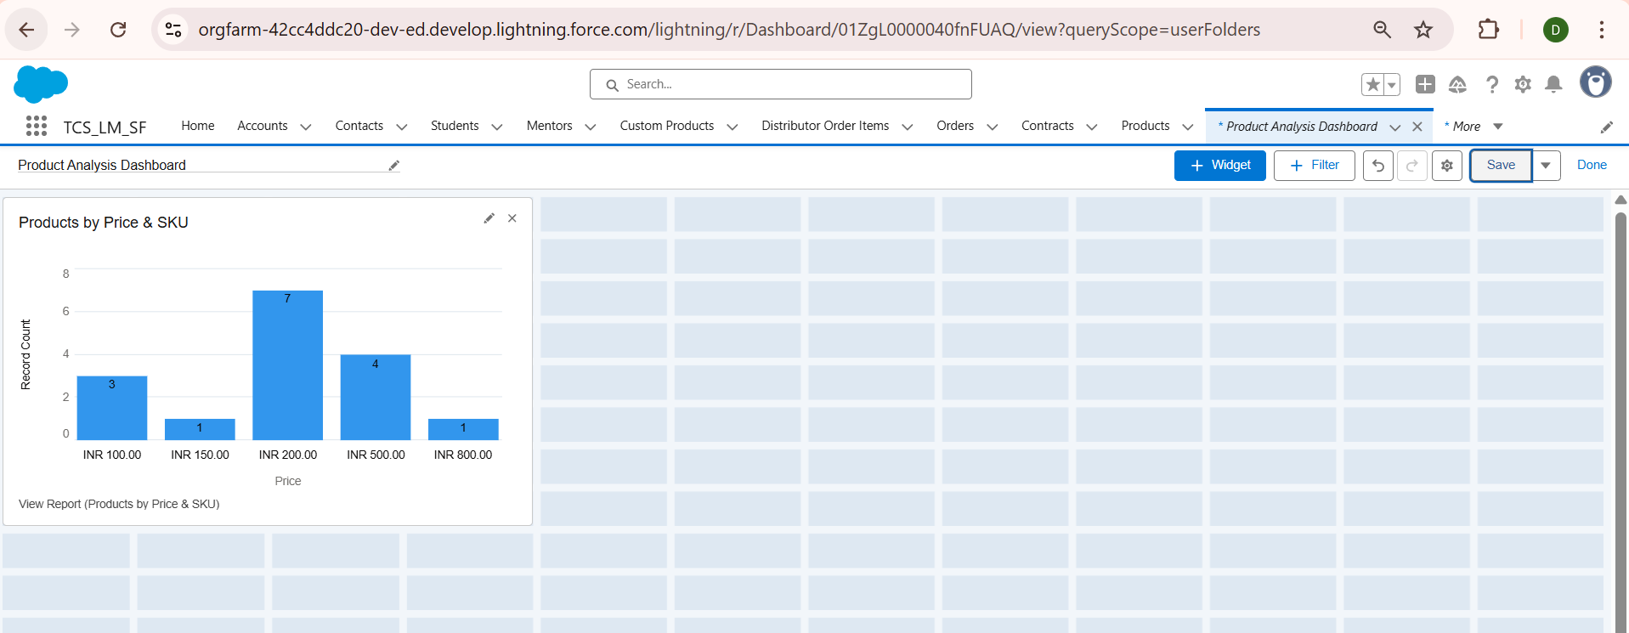

3. Items Not Implemented in Phase 9 (and Reason)
Within Phase 9, certain reporting and dashboard features were not implemented because they were not needed for this project:
- Joined Reports: Not required since analysis was limited to the Products object only.
- Advanced Filters and Cross-Object Reports: Not needed as we only focused on product-level details.
- Multiple Dashboard Tabs/Pages: A single dashboard view was sufficient for the client’s requirement.
- Dynamic Dashboards (per-user views): Not implemented because all users required the same standard product insights view.
By excluding these, we kept the reporting solution simple, relevant, and aligned with project objectives.

4. Outcome
- Successfully created Product Insights Report with Product ID, Name, Price, and SKU.
- Grouped the report by Price and SKU to identify product distribution patterns.
- Built a Product Insights Dashboard that provides a visual overview of product performance.
- Delivered an easy-to-use, centralized reporting tool for decision-making.

